MAPPING LAB OF UTAH
by: Maria F. Chavez
September 3, 2013

I DESERVE at least 90% on this Mapping Lab - see evidence below

LEARNING PROCESS:
1.WHAT I ALREADY KNOW: In my first mental map of Utah ( in my journal) I was only able to identify eight correct locations. This is sadly very disappointing for me. A couple of the other locations that I wrote down were slightly wrong but really close. Manti was a little bit too far to the right and Moab was slightly lower on the map then it actually is. I was also able to name all the surrounding states.
2. WHAT I WANT TO KNOW: There are so many different types of towns and counties in this state. I would like for me to able to learn more about the landmarks and rivers as well.My goal is to learn the name of at least 8 rivers, 10 cities, and to learn the difference between the uinta and wasatch mountains. I also want to be able to locate all these:
- Wasatch Mountains
- Great Basin
- Uinta Mountains
- Bonneville Salt Flats
- Book Cliffs
- Navajo Mountains
- Sevier River
- Sevier Lake
- Virgin River
- Mt. Pennell
- Abajo Peak\
So overall I want to be able to to name at least 25 physical and human features.

3. HOW I DID THIS:I played the city matching game for about 10 minutes and at first I only got 35% then I was able to get 100% in under a minute.
  - I studied an atlas of the counties for a few minutes.
  - I used the national geographic Utah map ( in mapmaker interactive) and was able to learn a few more things..
  - I also played the utah counties game and and at first I got 33% , then after 3 tries ones day, and 2 two times today, I got 100 %. Now it has been about 2 weeks and I can name all of the counties by memory without doing the game, just by looking at them.
  - And last but not least. I played the 20 places in utah game and got 100% now I know all of them by memory after two weeks.

4. REFLECTION ON FINAL MAP: On my final map I definitely showed a lot of growth by naming many more cities , rivers, mountains , and also some national parks. I studied a lot and learned a ton more of things. I was sort of oblivious to the assignment on my first map so i definitely could have had a lot more before. My final mental map though , even if i had gotten a few more locations recognized in my first map , is way beyond what I wanted to accomplish. I did forget a few cities that I wanted to include like Kanab and Panguitch , but I am overall happy with the growth I was able to show. After seeing an actual map of utah I counted and found that one little location was a little bit off but I got about 48 correct locations. Unlike my first mental map though I didn’t name the neighboring states. Also just a notice , I confused the state borders but sort of had the shape in mind.

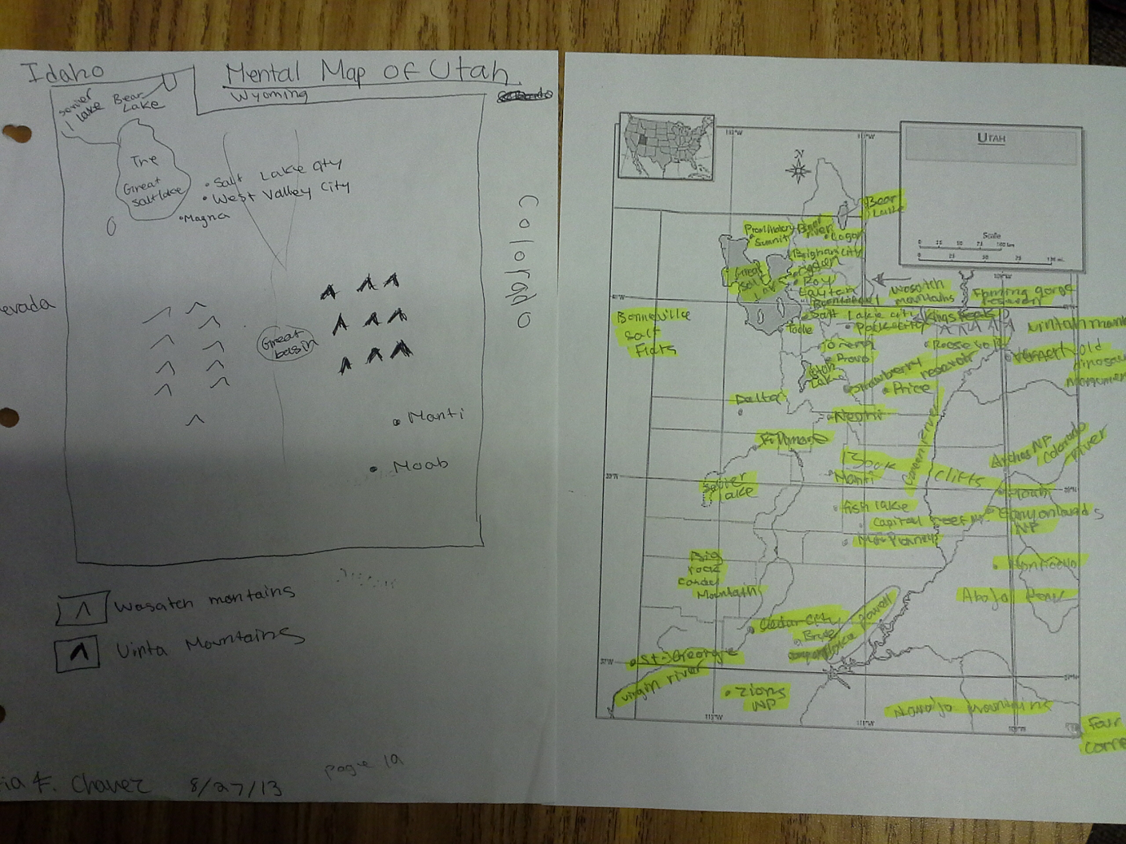
Here is my first mental map. This is my final mental map

