Information
Dental Habits:
Parts of a tooth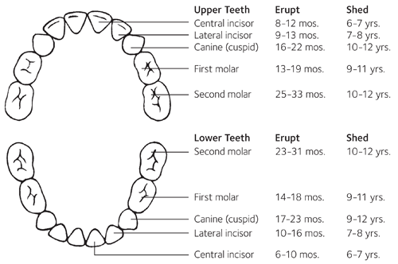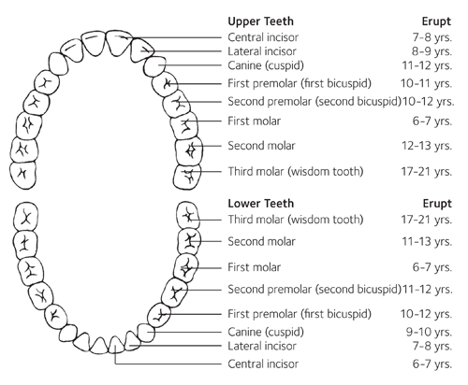
✯✯✯✯✯✯✯http://www.mouthhealthykids.org/en/educators/smile-smarts-dental-health-curriculum
http://www.ada.org/~/media/ADA/Publications/Files/for_the_dental_patient_dec_2010.pdf

Presenting to Children:
Have children discuss some of their favorite foods and write them under the appropriate group. Bring enough healthy snacks to share with the children and ask them to identify its food group.
http://www.choosemyplate.gov/myplate/index.aspx for sheets

Sources:
http://www.mouthhealthykids.org/en/educators/smile-smarts-dental-health-curriculum
http://www.mouthhealthy.org/en/az-topics/e/eruption-charts
https://www.123dentist.com/10-fun-facts-about-teeth/
http://www.ada.org/~/media/ADA/Publications/Files/for_the_dental_patient_dec_2010.pdf

Presentation Plans
Present to at least 3 classes
- Powerpoint
- Dental Kits
- Posters
- Fun activity (maybe make a game with foods, or make a dental model out of clay?)
- Brochures to take home
- MAKE MAGNETS TO TAKE HOME
- Schedule Presentation with Martha
LOG of Work
2016
10/20 Research on History of Dental Health
12/9 Research on Brushing and Flossing
2/10 Research on Nutritional Habits
2/16 Meeting with Martha to talk about my audience ( children’s center, different schools ( check schedule during A2, talk to Ms. Aho about using health book and possible presenting in class with a survey)

3/10 Planned with Ms. Aho to present to health classes
3/20 Dental Health Presentation to Health Classes
3/28 Dental Health Presentation at the Children’s Center

http://www.giggletimetoys.com/coloring_pages/dental/brush_everyday.pdf
http://www.momjunction.com/print-coloring-image/?pageid=90642&print=2014/09/The-four-fine-friends
http://www.momjunction.com/print-coloring-image/?pageid=90642&print=2014/09/The-Dental-Hygiene-color-page

